Title: Above All Guard your Heart 2020-05-17
Date: 2020/05/15
Place: GC
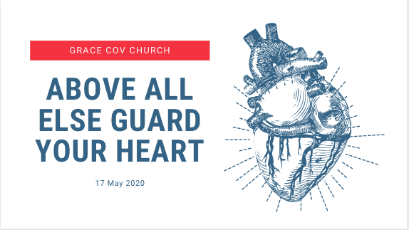
INTRODUCTION:
Good morning!
We’re recording today with no electricity, we had cable stolen during the night and with it a reminder that life carries on despite lockdown! It a strange reminder that we don’t live in a vacuum and that while Lockdown can be all consuming its not our whole world.
There is a future we are looking towards!

How’s Your Walk?
- Trust youre still running well, and instep with the Holy Spirit… How did this week go?
I felt it would be good for us just to take a beat, to pause and evaluate, to consider what God has said, and what He is asking of us… and what we need to ask of Him!

DIY Disciples – personal practices of people following Jesus
Easter

I felt this morning that rather than just rush into our next sermon series, that it would be good to PAUSE, to CATCH OUR BREATH and
We do not lack for information in this season!
Like a Teenage Son its Easy to finish our last bite of supper and ask, I’m hungry what can I eat?

The irony of Lockdown is that it’s a great leveller – we’re all going thru the same thing and facing mostly the same challenges!

I’m sure you, like me hoped for a clear roadmap on Wed pm when our President spoke.
I can only imagine the pressure he is under to please everyone! I trust you’re praying for him, whether you agree with him or not!
But truthfully we have very few milestones to work from.

So how do we navigate the next few weeks and months, if there is so much unknown facing us.
- Well the same way we face every season of life!
- I really believe that this Lockdown season has been an opportunity for us to Go to God and allow Him to RESET some things deep in us.

Proverbs 4: 23 Above all else, guard your heart, for everything you do flows from it.

NLT
23 Guard your heart above all else, for it determines the course of your life.

Good News Translation
Be careful how you think; your life is shaped by your thoughts.
World English Bible
…, for out of it is the wellspring of life.

Wow if EVERYTHING Flows from that
Guard // Preserve / Watch over / Keep
Heart // Thoughts / Will / Emotions / Seat of pride & rebellion /

HEART
- Everything you do flows from it.
- Shapes your life
- Is the wellspring of life
- Determines the course of your life

Wow – pretty strong stuff!
Best we watch carefully!

Mt 12:34 “out of the overflow of the heart, the mouth speaks”

- Guard your Heart!
- Heart vs23
- Mouth v24
  - No Perversity
  - No Corrupt talk
    - Carnal = ungodly
    - Carnal = Faithless!
  - Choose your words: Speak Life!
  - Self-Talk - Personal Manifesto!
- Eyes v25
  - Straight ahead
  - Fixed Gaze
  - Finish line
- Feet v26
  - Think carefully of the paths we take.
  - Often think as long as not ungodly paths I’m good!
  - No we were made for so much more!
  - Tefo Merc B class in Mokhotlong! Under pressure we evaluate, but how about PROACTIVELY?
  - Don’t waste what is left of Lockdown.
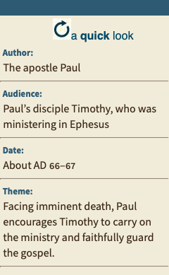
Paul was again imprisoned under Emperor Nero c. 66–67. It was during this time that he wrote 2 Timothy
In his first imprisonment, he lived in a “rented house” (Ac 28:30; see note there), he now languished in a cold dungeon (see 4:13 and note), chained like a common criminal (1:16; 2:9).
His friends even had a hard time finding out where he was being kept (1:17). Paul knew that his work was done and that his life was nearly at an end (4:6–8).
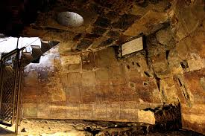

Paul is concerned about the welfare of the churches during this time of persecution under Nero, and he admonishes Timothy to keep on preaching the gospel and, if necessary, to suffer for it.
He writes to Timothy for 3 reasons:
- Paul was lonely. Deserted by some, faithful team traveling on ministry, only Luke with him.
- Paul was concerned about the welfare of the churches during this time of persecution under Nero, and he admonished Timothy to guard the gospel (1:14), to persevere in it (3:14), to keep on preaching it (4:2) and, if necessary, to suffer for it (1:8; 2:3).
- Paul wanted to encourage the Ephesian church through his letter to Timothy (see note on 4:22).

Its in this context – despite His personal suffering and death sentence that he Writes to Timothy “Guard the Good Deposit…”

Alexander the metal Smith personally opposed the apostle’s preaching.
As Timothy was now in Ephesus, where he was later martyred, in charge of the church there, he is strongly cautioned by the apostle to be on his guard against this opponent.

Remember Paul was a Jewish scholar, he would have known the old testament intimately.
It makes sense that the same Timothy who he told to not be afraid, would be told to Guard himself, with echoes of Pr in their thoughts.
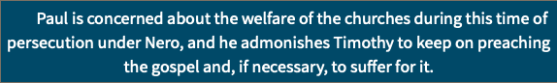

- What does the Bible say we must Guard?
- Guard my teachings Pr 7:2 I.e. What We BELIEVE
- 3 Those who guard their lips preserve their lives, but those who speak rashly will come to ruin. Pr 13:3 I.e. What We Say / How We Speak
- “Be on your guard against the yeast of the Pharisees and Sadducees.” Mt 16:6 Heartless Religion I.e. How We Respond (from heart or threat)
- So be on your guard! From those who distort the truth Act 20::31 I.e. What We Live / Present: E.G., Model, Teach,

- Paul & Timothy
  - Guard the Gospel.
1 Tim 6:20 Timothy, guard what has been entrusted to your care. Turn away from godless chatter and the opposing ideas of what is falsely called knowledge, 21 which some have professed and in so doing have departed from the faith.
- Timothy Entrusted with the gospel / truth nb vs false knowledge and departed from faith.
- What have you been entrusted with?
- “If a man has not discovered something that he will die for, he isn't fit to live. Martin Luther King, Jr.

  - Guard the Good Deposit
2 Tim 4: 14 Guard the good deposit that was entrusted to you—guard it with the help of the Holy Spirit who lives in us.
- 2 Cor 4: 7 But we have this treasure in jars of clay to show that this all-surpassing power is from God and not from us. 8 We are hard pressed on every side, but not crushed; perplexed, but not in despair; 9 persecuted, but not abandoned; struck down, but not destroyed.
- 16 Therefore we do not lose heart. Though outwardly we are wasting away, yet inwardly we are being renewed day by day.
- What Treasures Has God put inside of you?
- Deposit guarantees fulfilment.

  - Guard against Opposition
2 Tim 5: 15 You too should be on your guard against him, because he strongly opposed our message.
- Alexander the Metalsmith
- Ideas of the day
- The Mood of our Nation
- What are you Guarding Against?

- Pause: Stop and Consider
- Evaluate
  - Lets not just rush back to business as usual
  - Or waste the lessons and the dealings of God in this season
  - We often think we have less choices than we think

- Prepare
  - Heart, mind, Well.
  - Don’t just wander back into well-worn paths

- Gird
  - Prepare oneself for future action or challenge dangerous or difficult.
  - Lit “Tighten your pants! Tuck in your tunic so that you can work, run, fight.
  - Get ready / Man up!

- Budget
  - Often we think of budget means spend less.
  - Rather Spend on purpose!
  - Think thru the resources you have
    - Financial
    - Emotional
    - Family relationships
    - Work networks and synergies
- Prophetic
  - Is 30: 20 Although the Lord gives you the bread of adversity and the water of affliction, your teachers will be hidden no more; with your own eyes you will see them. 21 Whether you turn to the right or to the left, your ears will hear a voice behind you, saying, “This is the way; walk in it.”
  - We are in uncharted territory! There is no manual for returning from Lockdown. But God knows!
  - Treasure the Promises you carry
  - Seek His leading

- Affections
  - Be careful what captivates us
- To not Loose What was Hard Won in the Past
  - Friendships – had a virtual cup of coffee with someone lately?
  - Fellowship – connected on a spiritual lever with someone recently?
  - Witnessing – invited someone to church recently?

CONCLUSION:
If we aren’t intentional with our time, we find it disappears!
- What do you want to accomplish by month end?

Let’s not lose the victories from other seasons in this season.
Rather Guard your Heart, and LET IT BE A WELLSPRING OF LIFE!!

23 Above all else, guard your heart, for everything you do flows from it. 24 Keep your mouth free of perversity; keep corrupt talk far from your lips. 25 Let your eyes look straight ahead; fix your gaze directly before you. 26 Give careful thought to the paths for your feet and be steadfast in all your ways.

